Deriving User Requirements for Haptic Enhanced Automotive Touch Screen Interaction

Electricity Click feedback Edge feedback

【Main Content】:

Study user preferences for edge feedback and click feedback with haptic feedback devices.

The transition of button edges can be enriched by edge feedback. Different tactile cues can be provided to enable users to distinguish finger movements on buttons.

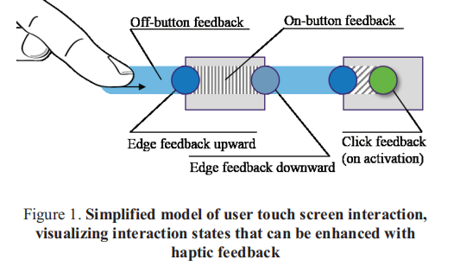

【Experiments】：

**Apparatus：**

Robert Bosch Corporate Research (Visaton EX45S)

4 different click feedback signals C1-C4 and 4 different edge feedback signals E1-E4

**Thesis conclusion:**

More than 70% of users prefer edge feedback.

Click on the feedback to select the results of the study which is a bit ambiguous.

Studied the effect of button size.

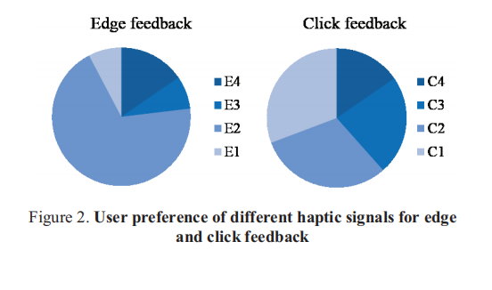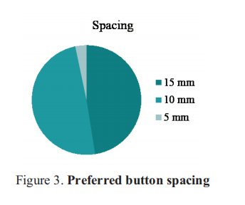

【Subjective analysis】：

**Advantages:**

1. Subjective effects of simulated tactile button size and spacing on users .
2. Subjective effects of different intensity edge feedback and different intensity click feedback on users.

**Disadvantages:**

1) Without discussion the impact on user efficiency.

2) No discussion of whether distractions can be reduced in a dynamic driving environment.

3) No and no use of edge feedback and click feedback. At the same time, experimenters are more subjective about which edge feedback and click feedback are more popular.

【Important References】：

[4] S. Kim, G. Lee. "Haptic feedback design for a virtual button along force-displacement curves." Proceedings of the 26th annual ACM symposium on User interface software and technology. ACM (2013)

[5] H.-Y. Chen et al. "Design and evaluation of identifiable key-click signals for mobile devices." Haptics, IEEE Transactions on 4.4, 229-241 (2011)

[6] G. Park et al. "Tactile effect design and evaluation for virtual buttons on a mobile device touchscreen." Proceedings of the 13th International Conference on Human Computer Interaction with Mobile Devices and Services. ACM (2011)